Introduction to graph

\*Data structures are ways to store and organize data. Array, linked list, stack and queue. All these are linear data structure. Tree is a non-linear data structure. Tree is hierarchical structure.

\*A graph just like a tree is a collection of objects or entities that we call nodes or vertices, connected to each other through a set of edges.

But in a tree connections are bound to be in a certain way. In a tree there are rules dictating the connection between nodes.

In a tree with N nodes we must exactly have N-1 edges. An edge in a tree is for parent-child relationship. In a tree all nodes should be reachable from root.

\*In a graph there are no rules dictating the connection among the nodes. A graph contains a set of nodes and a set of edges and edges can be connecting nodes in any possible way.

Tree is a only a special kind of graph

\*In mathematical terms

Graph:

A graph G is an ordered pair of a set V of vertices and a set E of edges.

G=(V,E)

(V,E) This is how we represent an ordered pair. Objects separated by comma put within parenthesis. Since order does matter here, V is the first object in the pair and E is the second object.

An ordered pair A,B is not equal to B,A unless A and B are equal.

Ordered pair

(a,b)#(b,a) if a#b --># is used to represent not equal to(!=)

Unordered pair

{a,b}={b,a}

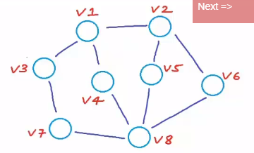

Edges

O------>O O------O

u v u v1

directed undirected

(u,v) {u,v}

For a directed edge one of the endpoint will be origin and other end point will be destination. A directed edge can be represented as an ordered pair.

For undirected edge connection is two way and undirected edge can be represented as unordered pair.

V={v1,v2,v3,v4,v5,v6,v7,v8}

E={{v1,v2},{v1,v3},{v1,v4},{v2,v5},{v2,v6},{v3,v7},{v4,v8},

{v5,v8},{v6,v8},{v7,v8}}

It is possible for a graph to have both directed and undirected edges, but we won't study such graphs and we are only going to study those graphs which has all directed or undirected edges.

\* A graph with all directed edges is called a directed graph or digraph and a graph undirected edges is called undirected graph.

\*A graph can be used to represent any kind of pairwise relationship.

Examples

1. Social network(facebook) is an undirected graph because friendship is mutual relationship.

Look at the image here 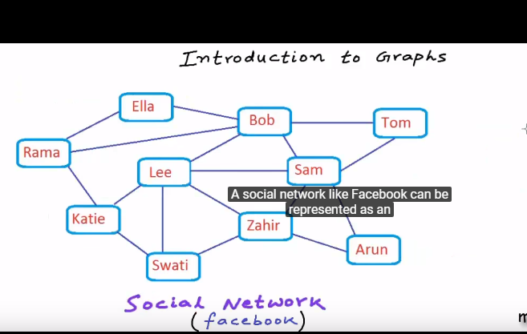

A user is a node in the graph and if two users are friend there will an edge connecting them.

Once we represent a system modeled as graph many problems can be solved by using standard algorithm of graph theory.

Lets suppose a problem statement as "suggest friends to a user Rama who are not connected to rama"

--We can suggest Tom, Sam, Lee and Swati.

In pure graph terms the problem can be re stated as Finding all nodes having length of shortest path from a given node equal to 2

2. Inter linked web pages on world wide web or Internet can be represented as a directed graph.

Look at the image here 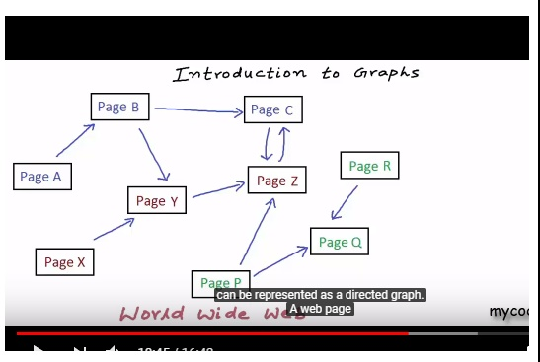

The edges in the graph are directed because the relationship is not mutual.

One of the tasks that search engines like Google perform very regularly is web crawling. Search engine uses a program web crawler which traverses through web pages.

Web-crawling is Graph Traversal

\* Weighted vs unweighted Graph

Sometimes in a graph all connections cannot be treated as equal. Some connections can be preferable to others.

We can represent intercity road network that is the network of highways and freeways between cities as an undirected graph. Lets assume all highways would be bi-directional.

Intra-city road network can definitely have one way so that can be represented as a directed graph.

Now clearly we cannot treat all connections equally here. Roads would be of different lengths and to perform a lot of tasks we would need to take length of the roads into account.

In such cases we associate some weight or cost with every edge. We label the edges with their weights.

Look at the image here 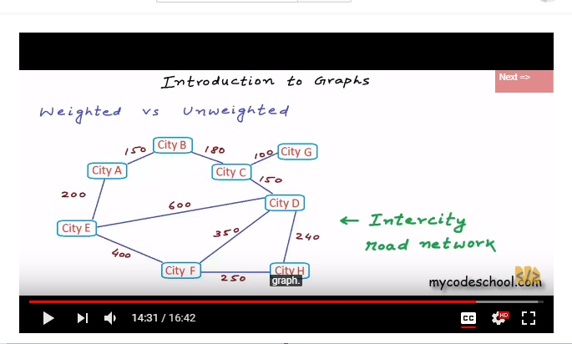

\* An unweighted graph can be seen as a weighted graph in which weight of all the edges are same and typically we assume weight as one.

\* We can always draw an undirected graph as directed by having 2 directed edges for each undirected edge. But we may not be able to draw a directed graph as undirected.